**Task 9:**

**The Pony Express**

Would you spend $5 to send a half-ounce letter that will take 10 days to get to California? That was the rate charged by the Pony Express, which in its day provided the fastest possible delivery to the west coast.

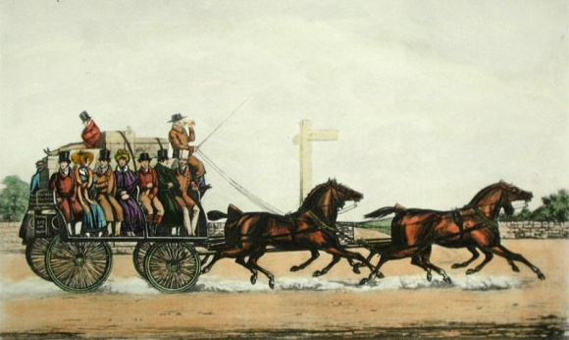The route of the Pony Express stretched 1966 miles from St. Joseph, Missouri, to Sacramento, California. Relay stations were set up every 10 to 15 miles along the way, where lonely keepers took care of the horses. Young riders rode at top speed from one station to the next for wages for $100 to $150 per month. In all, there were about 190 stations, 400 station keepers and assistants, 400 horses, and 80 riders. Despite the hardships of riding in all kinds of weather and the constant attacks by Indians and outlaws, the mail was lost only once in the more than 650,000 miles logged by the riders.